GRX (Group Excess) Salesforce Integration: Manual Process Design Document
Package: pkg_stone_river_data_load (schema STAGE_MISREG) | Prepared by: Pawan | Date: November 11, 2026 | Status: Draft v1.0 for client review

1. Purpose and scope
This document describes the changes made to the Stone River (SRM) monthly Manual process so that Group Excess (GRX) policies sourced from Salesforce (source system keys 23 and 24) flow through the existing Manual premium and claims process. It also explains the reasoning behind each design decision.
In scope: the four Manual procedures of pkg_stone_river_data_load: prc_premium_feed_load, prc_claims_feed_load, prc_premium_control_load and prc_claims_control_load.
Out of scope: the DC / CIP (Instanda) procedures, WINS, and DataStage job changes. These were reviewed for impact (Sections 8 and 9) but are not modified by this change.
Design goal: admit Salesforce GRX and nothing else, with no change to how existing Manual, DC and CIP business is selected, aggregated or reported.

2. Executive summary
- Problem: Before this change, Salesforce GRX was rejected by both selection rules. Premium admitted GRX only from the source-system names Manual and Program Connect; claims admitted only source system keys 6, 7 and 15.
- Solution: A narrowly scoped Salesforce admission rule was added to all four Manual procedures. A Salesforce row is admitted only when the source-system name is SF Admitted or SF Non-Admitted, the source system key is 23 or 24, and the policy type is GRX.
- Month basis: Salesforce claim transactions are selected on the PCS accounting month (pcs_month_acctng_ct). All other sources keep the existing accounting month (month_acctng_ct).
- Unchanged: output record layouts, product mapping (GRX to GEX to line of business 171), orchestration order and the structure of the control totals.
Measure | Count
Manual procedures modified | 4
Functional edits | 22
of which premium selection (1 feed, 1 control) | 2
of which claims admission filter (5 feed, 5 control) | 10
of which claims month basis (5 feed, 5 control) | 10
DC / CIP procedures with no logic change | 6 (two carry a whitespace or comment-only edit)

3. How the Manual process works
The monthly run is orchestrated by prc_policy_data_load(in_ym). The run month in_ym is a YYYYMM value that defaults to the previous calendar month. The orchestrator calls the four Manual procedures in the fixed order below, followed by the DC / CIP procedures. Each step commits and writes to the run log, and any failure is raised and stops the run. Each Manual procedure deletes the existing rows for the run month (param_num = in_ym) before inserting, so a month can be safely re-run.
Step | Procedure | Log module | What it builds | Target table (STAGE_MISREG)
1 | prc_premium_feed_load | MANUAL_PRM | Fixed-width premium records from TTRANSACTION, grouped by endorsement, policy, coverage, transaction type and dates | stage_premium_feed_details
2 | prc_claims_feed_load | MANUAL_CLAIMS | Loss records from TCLAIM_TRANSACTION in five blocks: paid loss, paid expense, salvage and subrogation, other recovery, reserves | stage_loss_feed_details
3 | prc_premium_control_load | MANUAL_CONTROL | Product-level premium control totals, using the same selection as step 1 | stage_premium_control_details
4 | prc_claims_control_load | MANUAL_CLAIMS_CONTROL | Product-level loss control totals, using the same selection as step 2 | stage_loss_control_details

4. End-to-end process flow
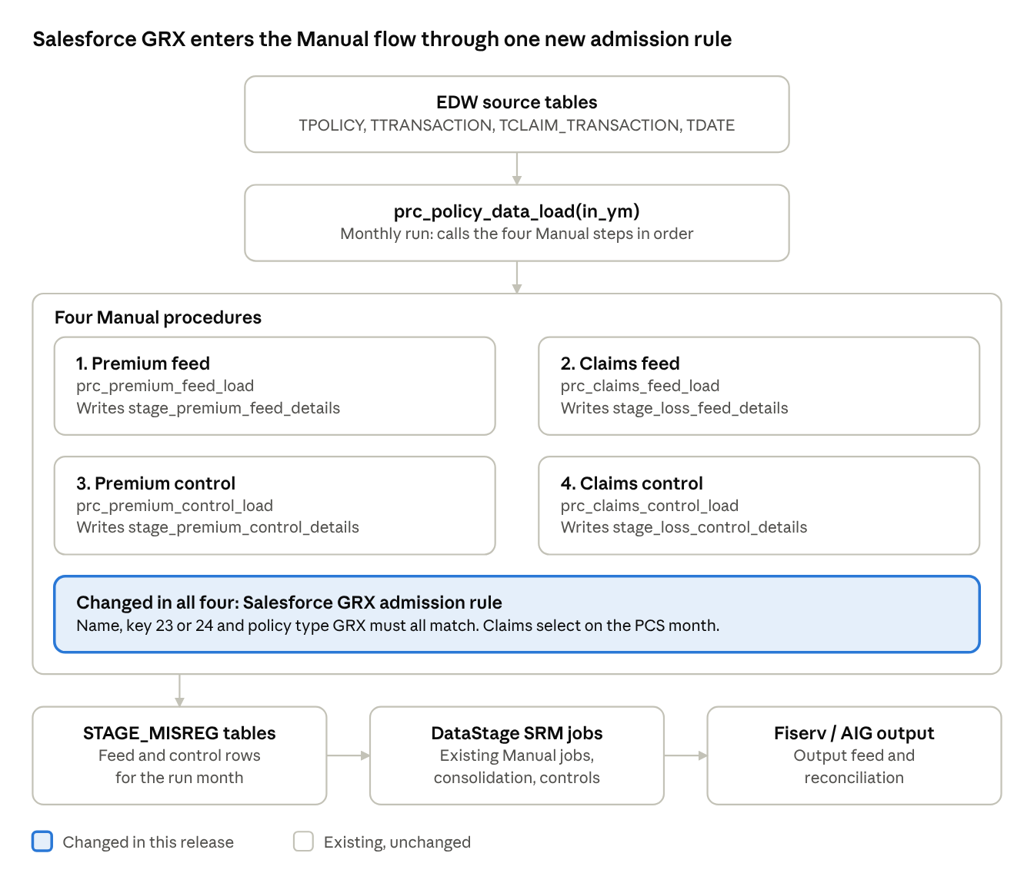
Manual process flow: 4 procedures, 1 change point
The Salesforce rule is applied inside the four Manual procedures (highlighted). The orchestrator, stage tables and DataStage jobs around them keep their existing design. The numbered steps below give the detail.
- Source data (EDW): TPOLICY, TTRANSACTION, TCLAIM_TRANSACTION, TCLAIM, TPOLICY_TYPE, TUW_COMPANY, TDATE and related reference tables.
- Orchestration: prc_policy_data_load(in_ym) runs the four Manual procedures in order.
- Row admission (changed in this release): each procedure decides which policies and transactions are admitted. Existing Manual business is admitted exactly as before; Salesforce GRX is now admitted by the new rule below.
- Month selection: premium uses the accounting-date month (year_month_ct); claims use month_acctng_ct (existing sources) or pcs_month_acctng_ct (Salesforce).
- Mapping and enrichment: policy type GRX maps to product GEX and line of business 171; account enrichment is applied; the fixed-width record is built.
- Stage tables: four feed and control tables in STAGE_MISREG.
- DataStage SRM jobs (existing): the Manual-lane jobs (SRM_EXTRACT, TURS_MANUAL_PREMIUM_DS, TURS_MANUAL_LOSS_DS, SRM_MANUAL_PREMIUM_DS, SRM_MANUAL_LOSS_DS), consolidation (SRM_FUNNEL_DS) and the control and reconciliation jobs consume the stage tables and produce the Fiserv / AIG output.

Salesforce GRX admission rule
Check | Premium (feed and control) | Claims (feed and control)
Run month | year_month_ct = in_ym on the accounting date | Salesforce: pcs_month_acctng_ct = in_ym. Other sources: month_acctng_ct = in_ym. Reserves use <= in_ym (cumulative) on the same columns
Source system key | IN (23, 24) | IN (23, 24)
Source system name | SF Admitted or SF Non-Admitted | SF Admitted or SF Non-Admitted
Policy type | GRX | GRX
Amount | premium_am <> 0 | The amount for the block (loss paid, expense paid, recovery or reserve) is non-zero
Existing exclusions kept | Unchanged | HP policy type excluded; UW company suffix 51 and 61 excluded

5. Design decisions and reasoning

5.1 Keep Salesforce GRX in the Manual lane
- GRX has always been processed through the Manual lane and does not appear anywhere in the DC / CIP procedures. Those procedures admit policy types EXFL, HO, AU, PE, PC, EQ, CHO, CAU and YHT from source system keys 16 to 21.
- Reusing the Manual lane keeps the existing record layout, product mapping and control structure. No new feed format, table or orchestration step is needed.
- Moving GRX into DC / CIP would require new branches in six procedures and different downstream jobs, a much larger change with higher regression risk.

5.2 Three-part admission rule: name, key and policy type
- Policy type = GRX keeps other Salesforce products out of the feed until they are explicitly onboarded.
- Source system name and key together make the rule exact. A row must carry both a Salesforce name and key 23 or 24.
- Explicit names, not a pattern. The rule lists SF Admitted and SF Non-Admitted instead of a wildcard, so no unrelated source system can match by accident. An earlier iteration matched the literal name Salesforce, which does not match the names carried on the policy; the final rule uses the actual names.

5.3 PCS accounting month for Salesforce claims
- The claims transaction selection is split into two mutually exclusive branches: transactions with source system key not in (23, 24) use month_acctng_ct exactly as before; transactions with key 23 or 24 use pcs_month_acctng_ct.
- No regression: the existing branch is logically identical to the production logic for every source other than 23 and 24.
- No double counting: because the branches are mutually exclusive, a transaction is evaluated under exactly one calendar.
- Established convention: the DC / CIP procedures in the same package (prc_cip_premium_feed_load, prc_cip_claims_feed_load) already select activity on pcs_month_acctng_ct.
- Reserve blocks keep their cumulative form (<= in_ym) on the chosen column.

5.4 Premium: admission filter only
For premium, only the admission filter was changed. Month selection is unchanged (year_month_ct on the accounting date) for all sources, following the principle of the smallest possible change. See Section 12, item 1.

5.5 Product and line-of-business mapping unchanged
Product comes from tpolicy_type.pol_type_wins_cd and line of business from the existing mapping (GEX to 171). Neither depends on source system, so Salesforce GRX resolves to the same product and line of business as existing Manual GRX with no code change.

5.6 Feed and control changed identically
The control procedures use the same selection as the feed procedures. All 22 edits are mirrored so that control totals reconcile to the feed records.

6. Change register
Line numbers refer to the delivered package file. The 13 --Pawan markers sit on the premium filters (2), the claims admission filters (10) and one existing Instanda filter annotation (comment only).

6.1 Premium (2 edits)
ID | Procedure | Change | Lines
P-1 | prc_premium_feed_load | Added Salesforce GRX branch to the WHERE clause | 4061 to 4065 (WHERE at 4057 to 4068)
P-2 | prc_premium_control_load | Same change, mirrors P-1 | 9802 to 9806 (WHERE at 9798 to 9809)

6.2 Claims feed: prc_claims_feed_load (10 edits)
ID | Block | Month basis edit | Admission filter edit
C-1 | Other recovery | 4754 to 4764 | 4782 to 4789
C-2 | Reserves (cumulative) | 5385 to 5395 | 5413 to 5420
C-3 | Paid loss | 6201 to 6211 | 6229 to 6236
C-4 | Paid expense / LAE | 6826 to 6836 | 6854 to 6861
C-5 | Salvage and subrogation | 7461 to 7471 | 7489 to 7496

6.3 Claims control: prc_claims_control_load (10 edits)
ID | Block | Month basis edit | Admission filter edit
C-6 | Paid loss | 10448 to 10458 | 10477 to 10484
C-7 | Paid expense / LAE | 11054 to 11064 | 11083 to 11090
C-8 | Salvage and subrogation | 11664 to 11674 | 11693 to 11700
C-9 | Other recovery | 12273 to 12283 | 12302 to 12309
C-10 | Reserves (cumulative) | 12879 to 12889 | 12908 to 12915
The control procedure orders its five blocks differently from the feed procedure; each block carries the same logic in both.

6.4 Non-functional edits
- prc_cip_premium_feed_load, line 16551: whitespace only in an existing CASE expression (18, 19, 20,21). No behaviour change.
- prc_cip_claims_feed_load, line 17802: --pawan annotation appended to the existing Instanda filter (source system keys 16 to 21). Comment only. Salesforce was deliberately not added to the DC / CIP lane.

7. Representative before and after code
Premium selection (P-1 and P-2), before:
WHERE
( ( a.source_system_nm IN ( 'Manual', 'Program Connect' )
AND a.source_system_sk NOT IN ( 2, 14 )
AND TRIM(a.policy_type_cd) IN ( 'EPLI', 'EQ', 'EXFL', 'GRX', 'PC' ) )
OR ( a.source_system_nm = 'AIWCS'
AND TRIM(a.policy_type_cd) = 'WC' ) )
AND c.premium_am <> 0
After:
WHERE
( ( a.source_system_nm IN ( 'Manual', 'Program Connect' )
AND a.source_system_sk NOT IN ( 2, 14 )
AND TRIM(a.policy_type_cd) IN ( 'EPLI', 'EQ', 'EXFL', 'GRX', 'PC' ) )
OR ( TRIM(a.source_system_nm) IN ( 'SF Admitted', 'SF Non-Admitted' ) -- new
AND a.source_system_sk IN ( 23, 24 ) -- new
AND TRIM(a.policy_type_cd) = 'GRX' ) -- new
OR ( a.source_system_nm = 'AIWCS'
AND TRIM(a.policy_type_cd) = 'WC' ) )
AND c.premium_am <> 0
Claims month basis (C-1 to C-10), shown for a current-month block. Before:
AND t4.month_acctng_ct = in_ym
After:
AND (
( t4.month_acctng_ct = in_ym
AND t3.source_system_sk NOT IN (23,24) )
OR ( t4.pcs_month_acctng_ct = in_ym
AND t3.source_system_sk IN (23,24) )
)
Reserve blocks (C-2 and C-10) use <= in_ym in both branches.
Claims admission filter (C-1 to C-10), before:
AND l.source_system_sk IN ( 6, 7, 15 )
After:
AND (
l.source_system_sk IN (6, 7, 15)
OR ( l.source_system_sk IN (23, 24)
AND TRIM(a.source_system_nm) IN ('SF Admitted','SF Non-Admitted')
AND TRIM(a.policy_type_cd) = 'GRX' )
)

8. What was intentionally not changed
- The orchestrator prc_policy_data_load, its run order, commit and error-handling pattern.
- Output record layouts and column lists of all four stage tables.
- Product and line-of-business mapping (GRX to GEX to 171) and the existing Manual / Program Connect and AIWCS branches.
- Existing exclusions: HP policy type, UW company suffix 51 and 61, and the Canada / processing-office behaviour already in the premium branch.
- The DC / CIP procedures (policy types EXFL, HO, AU, PE, PC, EQ, CHO, CAU, YHT; source system keys 16 to 21) and prc_client_entry_load.

9. Downstream impact (DataStage and reporting)
- Flow: Salesforce GRX rows land in the same four stage tables, so they are consumed by the existing Manual DataStage jobs. No change to the job design is needed for the rows to flow; the transaction-ID re-labelling below is a separate enhancement.
- Transaction ID prefix: SRM_MANUAL_PREMIUM_DS and SRM_MANUAL_LOSS_DS build SRM_OUTGOING_TRANSACTION_ID with a fixed MP or ML prefix for every row they process. Salesforce GRX will therefore carry MP / ML until the separate re-labelling change (SP / SL) is implemented. That change is tracked outside this package.
- Control totals: the PL/SQL control tables group by product (AIG-PRODUCT). Salesforce GRX and existing Manual GRX will therefore aggregate together under GEX. Reporting them separately would be a further enhancement.
- Reconciliation reports group by the source-system tag assigned per DataStage job, so Salesforce GRX follows the Manual job's tag until a separate change is made.

10. Validation approach
- Regression run: run the baseline package and the delivered package for the same closed month in a lower environment. Output for all non-Salesforce rows must be identical; the only difference is the added Salesforce GRX rows.
- Expected admission count (premium):
SELECT TRIM(a.source_system_nm) AS source_system_nm,
a.source_system_sk,
COUNT(*) AS txn_count,
SUM(t1.premium_am) AS premium_am
FROM ttransaction t1
JOIN tdate t2 ON t1.accounting_dt_sk = t2.date_sk
JOIN tpolicy a ON a.policy_sk = t1.policy_sk
WHERE t2.year_month_ct = :in_ym
AND t1.premium_am <> 0
AND TRIM(a.source_system_nm) IN ('SF Admitted','SF Non-Admitted')
AND a.source_system_sk IN (23, 24)
AND TRIM(a.policy_type_cd) = 'GRX'
GROUP BY TRIM(a.source_system_nm), a.source_system_sk;
- Expected admission count (claims): the same check on tclaim_transaction joined to tdate using pcs_month_acctng_ct = :in_ym and source_system_sk IN (23, 24), repeated for each of the five amount types.
- Negative tests: a Salesforce policy of any other policy type, and a Salesforce GRX policy with a source-system name outside the two listed, must produce no rows in any stage table.
- Feed to control reconciliation: for the test month, control totals for product GEX must equal the totals derived from the feed records.
- Idempotence: re-run the same month and confirm the stage tables return to the same row counts.

11. Risks and mitigations
Risk | Mitigation
Other Salesforce products are pulled into the feed | Policy type = GRX is part of every admission rule
Month-basis change affects existing Manual claims | Mutually exclusive branches; the existing branch is unchanged for every source other than keys 23 and 24
Feed and control totals drift apart | All 22 edits mirrored across feed and control
A new Salesforce source-system name is introduced | Explicit name list: a new name is excluded until a deliberate code change and review
Rows with a null source system key | No behaviour change: such rows were already excluded by the existing key filter
Premium and claims calendars differ for Salesforce | Open item 1 below

12. Open items to confirm before sign-off
- Calendar consistency: Salesforce claims are selected on pcs_month_acctng_ct while Salesforce premium uses year_month_ct. Confirm with the business owner that this matches the intended Salesforce close calendar, or align premium.
- PCS calendar rationale: confirm the business rationale for using the PCS accounting month for Salesforce claims.
- Source-system names and keys: confirm that SF Admitted and SF Non-Admitted are always carried with keys 23 and 24, and that no other Salesforce names or keys are expected.
- DataStage extract: SRM_EXTRACT resolves its source tables through job parameters; confirm at runtime that it applies no source-system filter.
- Transaction ID re-labelling: confirm ownership and timing of the MP / ML to SP / SL change (Section 9).

Appendix A. Change inventory against the production baseline
Category | Count
Functional edits | 22 (2 premium, 10 claims filter, 10 claims month basis)
Whitespace-only edit | 1 (prc_cip_premium_feed_load)
Comment-only annotation | 1 (prc_cip_claims_feed_load)
--Pawan markers in code | 13 (2 premium, 10 claims filter, 1 annotation)
Remaining references to the test schema | 0

